

**Wellbeing Boost for Schools Week Nine – ACCEPTANCE**

**Be comfortable with who you are**

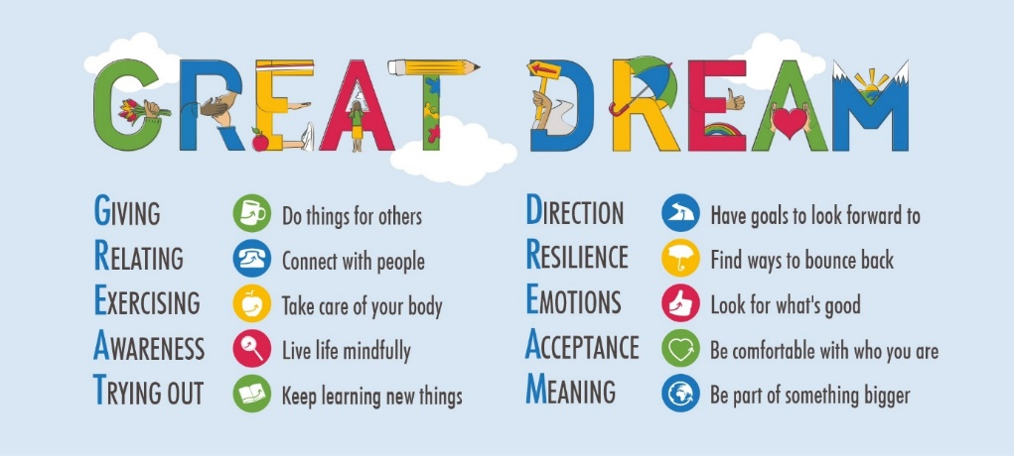 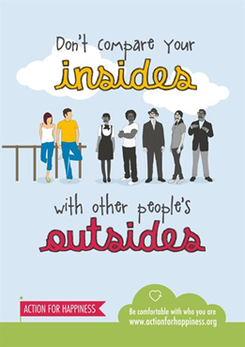

Dear Colleagues

Welcome to our ninth Wellbeing Boost of the term – ACCEPTANCE. This is about being comfortable with who you are, not comparing yourself constantly with others or trying to live up to what your parents want you to be. It is about treating yourself with kindness and understanding that we are all different. It helps if you know yourself too, what your strengths are and how we are all made up of different parts – some more likeable parts than others!

A good place to start is with ourselves. I would guess that many of you reading this are better at looking after others than looking after yourselves. This quote from Carl Rogers, the American Psychologist, reflecting back on his life at the age of 75 is pertinent for many people who are concerned about the wellbeing of others.

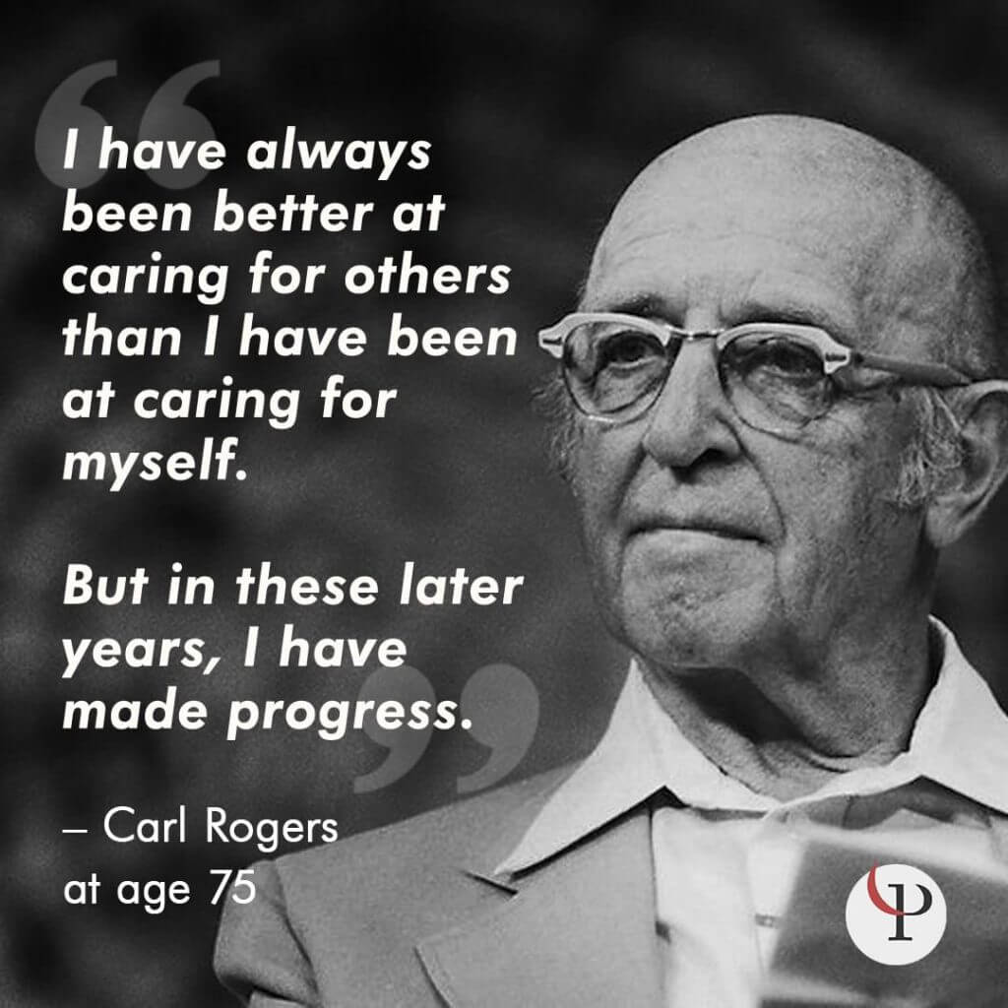

Some of you know that half of my current role is to help schools and provide support for children in care. Many of these children and others in school may find it extremely difficult to find acceptance of who they are, because they have experienced loss and rejection by adults around them and possibly experience great ‘shame’ around who they are. This can be true for other children, young people and adults who have experienced loss and rejection too. One of the models I use in schools was created by Dan Hughes, a Clinical Psychologist, it is based on the letters PACE – Playfulness Acceptance Curiosity and Empathy. <https://ddpnetwork.org/about-ddp/meant-pace/> If we can demonstrate those qualities to the children we work or live with, then they will feel accepted for who they are, even if we don’t accept their behaviour. (It is great to use with ourselves too.)

**Things to do for ourselves and with the children**

* Be as kind to yourself as you would be with others.
* Jot down the things that you do well – your strengths. This may help you <https://positivepsychology.com/what-are-your-strengths/>
* When you notice the things you do well, how do you feel?
* Celebrate your successes. Nobody is perfect – we all make mistakes.
* Ask a good friend what your strengths are – jot them down.
* Help children to make a strengths chain at home or school <https://www.understood.org/en/friends-feelings/empowering-your-child/building-on-strengths/strengths-chain-for-kids>
* Some sentence stems you could use with children could be; *‘My friends/ my Mum/my Teacher would say I am good at………………….. or ‘ When I am at my best I ……………….’*
* Share this lovely story with the children, ‘The Penguin and the Snake,’ a story all about self-acceptance. <https://www.youtube.com/watch?v=z-2zKjiondE> If you prefer to read it to the children it is available here <https://winlake64.wordpress.com/2011/08/17/penguin-parable-on-self-acceptance/>
* For parents this is a great article on how to identify strengths and parent your children based on their strengths. <https://greatergood.berkeley.edu/article/item/how_to_be_a_strength_based_parent_for_kids_with_learning_differences>

Have a look at Kintsugi, a really helpful metaphor when thinking about perfection and self-acceptance, for yourselves, children and families. *Kintsugi, as the practice is known, gives new life, healing or rebirth to damaged or aging ceramic objects by celebrating their flaws and history. One can consider how we might live a kintsugi life, finding value in the missing pieces, cracks and chips – bringing to light the scars that have come from life experiences, finding new purpose and meaning through aging and loss, seeing love and the beauty of 'imperfection' and loving ourselves, family and friends even with flaws.* Read more about it here. <http://lakesidepottery.com/Pages/kintsugi-repairing-ceramic-with-gold-and-lacquer-better-than-new.htm>

Maybe some of you still haven’t visited [www.actionforhappiness.org](http://www.actionforhappiness.org) which is the home of all this work based on GREAT DREAM. Try the coaching programme, which takes only a few minutes every day for 10 days. Did you look at <https://livespiffy.co.uk/> ? If you didn’t then you may really like it.

My sincere thanks go to Peter Harper, Val Payne and Vanessa King for their ideas and resources so well described in their book, ’50 Ways to Feel Happy.’

I hope your wellbeing has been boosted by the return to school for many children, if not please talk with someone about it.

John Fardon (Education Inclusion Officer – Mental Health)