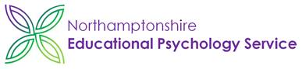

**Wellbeing Boost for Schools – Week Ten – Meaning**

**‘Be part of something bigger.’**

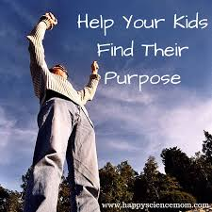

Dear Colleagues

Welcome to our last Wellbeing Boost this term, which is about ‘Meaning – being part of something bigger.’ This could mean that we recognise something outside or inside ourselves that gives us a sense of purpose or meaning. For adults it could be a vocation, a calling or a faith. For children it could be about being part of an organisation that is bigger than the individual child, such as cubs, groups of children that love the same activities like Forest School or being part of a group that wants to make a difference to society. Have a look at this film clip.

<https://confidentparentsconfidentkids.org/2017/11/30/in-search-of-purpose/> It is hard enough for us as adults to know what gives meaning or purpose to our lives, although for some of us it is clear; for children I would see it as part of our role as teacher or parent to help them discover what that might be.

Help the children to see how they are connected with the world around them.

* Ask them to draw a cartoon picture of themselves in the centre of an A4 page, then to draw connections (lines) with family, friends, activities and things about the world or universe they are really interested in. For those that don’t want to draw they could make lists.
* Ask the children what they would like to do when they grow up. How might they be able make a difference to the world?
* Ask the children to talk about what they already do to make a difference, even if it is to one person. Read this story to see what making a difference might mean. (Have a look at Protective Behaviours too!) <https://www.protectivebehaviours.org/protective-behaviours-resources-training-room/stories/68-the-starfish-story>

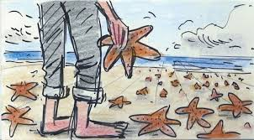

* Children could create their own coat of arms representing what has meaning for them in life, or a collage of images drawn or copied online.
* Create a research project with your children, asking them to find out about any people in the world that have made a positive difference to the world. Here are 40 examples, so click on each picture to find out what these children did, like Greta Thunberg or 9 year old Jahkil Jackson who helped the homeless in Chicago, with 3000 blessings bags. <https://www.goodhousekeeping.com/life/inspirational-stories/g5188/kids-who-changed-the-world/?slide=1>
* Think about what you could do as a class, school or family to make a difference to others and give a sense of purpose or meaning to life.
* Have you seen this? <https://thehappynewspaper.com/education/>
* <https://biglifejournal.com/blogs/blog/ways-children-make-difference> There is a teen version of this journal too.

Felicity Pirie from Brixworth Primary School has written to me to say how she has use these wellbeing boosts in her school; ‘*We have written an article for parents/carers in our newsletter (using ideas and quotes from your emails) every week since we started in January, as well as doing a weekly staff meeting input. While we were in lockdown I recorded an assembly for the children and I am now doing these via Zoom.*’

So what next for you and for where you live and work? What could you do to make even more of a difference to the lives of the staff, the children and families you work with? Brixworth have some ideas. ‘*Our aim is to start the academic year with a collective worship series on the 10 Keys, have displays round the school (including in the staff room for adult wellbeing), create ‘toolkits’ for children to refer to and write regular articles for the school newsletter’s ‘Wellbeing Corner’.*

*Thank you again for all the weekly information you have sent out. We have gathered so many ideas from them and I feel that our Mental Health strategy is a lot stronger now that we have worked through the keys.’*

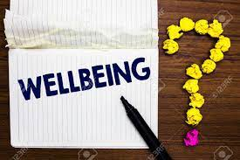

When you have had a bit of a break at Easter and maybe some time to reflect I would really appreciate it if you could share any resources or stories of how you have used the 10 Keys to benefit your schools, communities and families. My email will change on 1st April, but I will still work across the whole county. It will be [John.Fardon@westnorthants.gov.uk](mailto:John.Fardon@westnorthants.gov.uk) if you wish to share anything.

I will send out another Wellbeing Boost on April 23rd and maybe every month after that until the end of the Summer Term. What would help you most?

Wishing everyone health and wellbeing as we move towards the Summer Term. Please continue to share with colleagues, friends and family - even if you are weeks behind with these emails.

John Fardon (Education Inclusion Officer – Mental Health)